Phonics at Cooperative Education East
This policy contains the aims and working practice for Phonics at Thompson, Bunwell and Banham Primary Schools.

Phonics Lead Teacher at Trust Level: Natasha Clarke

Policy agreed by staff: September 2022

Policy viewed by governors: September 2022

Policy to be reviewed: September 2025

Introduction
At Co Operative Education East (CEE) we follow the Monster Phonics DfE approved phonics scheme. Monster Phonics is a rigorous, systematic synthetic programme developed by Ingrid Connors, a primary teacher, phonics specialist and audiological scientist. All of the resources within the programme are mapped against the Letters and Sounds phases 1 to 6 and the Key Stage 1 (KS1) Spelling Curriculum. It is a whole class scheme with decodable books for children in Reception and KS1. It is also used as an intervention in Key Stages 1 and 2.
Within CEE we believe that early, effective phonics teaching and learning is essential for achieving high attainment in reading and writing. Additionally, children’s confidence with phonics is integral to the curriculum and is used in all subjects. Achievement in this area benefits every area of pupils’ development and the school as a whole.
This policy is aimed at reinforcing a consistent, high quality approach to the teaching of phonics across the Early Years Foundation Stage (EYFS), Key Stage One and on into Key Stage two (KS2) for children who require further support.
A strong systematic synthetic phonics programme will help us to develop fluency, vocabulary and comprehension skills. By combining the technical skills needed to read alongside an enjoyment of and in reading we want children to possess a love of reading.

‘Young people who enjoy reading are three times more likely to read above the level expected for their age than children who don’t enjoy reading.’
National literacy Trust 2019

Our Aim

At Cooperative Education East, we aim to deliver high quality phonics teaching which secures the crucial skills needed in reading and writing. We aim to embed a strong phonic knowledge to enable the children to become fluent and confident readers. We want to establish a clear and consistent practice where prior knowledge is built upon and progression is clearly visible throughout the school. This will then make confident, able, responsible and effective learners of our children (CARE) which they can take forward into lifelong learning.
Our steps to achieve this whilst working within the Monster Phonics scheme:
- To teach children aural discrimination, phonemic awareness, alliteration and rhyme to aid reading, writing and spelling development.
- To encourage the use of segmenting and blending so that decoding skills provide a sound foundation for reading, writing and spelling.
- To ensure that the teaching of phonics is lively, interactive and inclusive.
- To enable children to use their phonological awareness across the curriculum.
- To ensure that children know the 44 phonemes within the English language.
- To teach children to recognise the graphemes within words and associate them with the appropriate phoneme when reading.
- To provide children with strategies to identify and decode Common Exception and High Frequency words.

Objectives
- To provide consistent, high quality phonics teaching that ensures all children have a strong foundation upon which to tackle the complexity of reading and writing.
- To ensure that teaching of synthetic phonics is systematic and progressive throughout the Foundation stage, Key Stage One and Key Stage Two for those children needing interventions to support phonemic knowledge and understanding.
- To ensure that children have a sound phonetic knowledge, understanding and skills so that they can decode words with confidence and engage with higher order reading and writing skills.

What is Phonics?
Phonics is a method of teaching children to read by linking sounds (phonemes) and the symbols that represent them (graphemes, or letter groups).
‘Phonics is a way of teaching children how to read and write. It helps children hear, identify and use different sounds that distinguish one word from another in the English language. Written language can be compared to a code, so knowing the sounds of individual letters and how those letters sound when they’re combined will help children decode words as they read.’
National Literacy Trust

What is a Phoneme?
A phoneme is the smallest unit of sound.
The phonemes used when speaking English are:
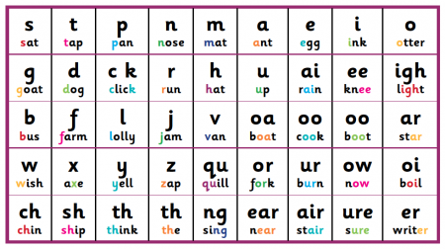

Teaching and Learning

Monster Phonics uses colour to consistently code for key graphemes in English. Colour shows children how to pronounce the most difficult aspects of reading. It is unique in that it uses character (monster) phoneme cues and colour coding to represent the long vowel sounds, silent letters and tricky letters. With Monster Phonics, spellings are more memorable and learning to read and spell becomes exciting and fun!
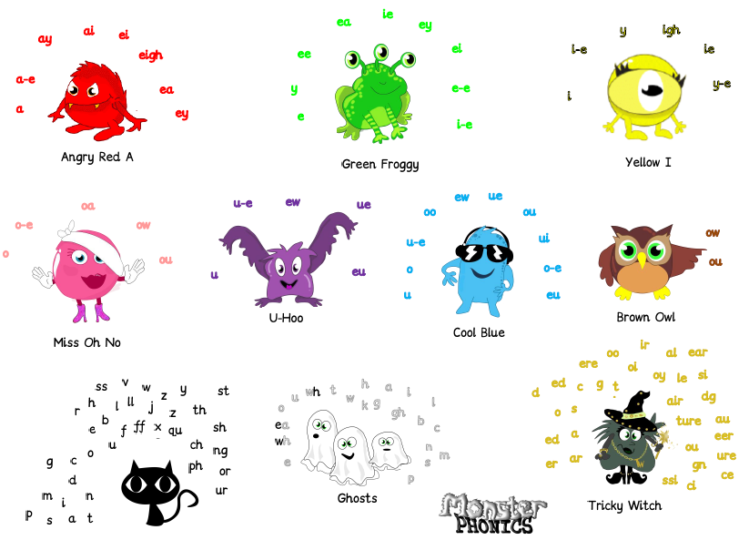

The colour-coding system aims to accelerate learning to read and spell. It uses colour coding for sound and audio-visual cues (monsters) to bring phonics teaching to life. Monster Phonics best supports children with dyslexia because it is by far the most multisensory scheme available.
Visual learners benefit from the visual memory of colour in words. EAL learners have pronunciation support for every word that they learn. Monster Phonics highlights the existence of the open syllable spelling of long vowels A, E, I, O and U, such as in be, no, apron, open, me which many young learners misspell.

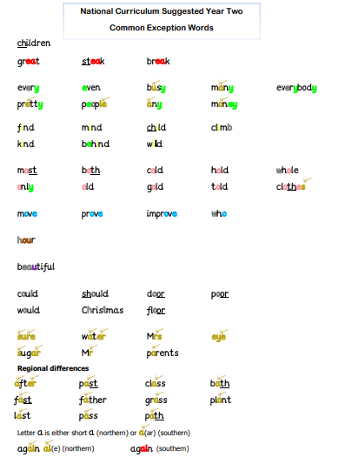

Bunwell Primary School - Phonics in Nursery

Children within our Nursery start phonics at the point of entry with teaching and learning being covered by Phase 1 of Letters and Sounds.
Phase 1 concentrates on developing children's speaking and listening skills and lays the foundations for the phonic work which starts in Phase 2. The emphasis during Phase 1 is to get children attuned to the sounds around them and ready to begin developing oral blending and segmenting skills.
Phase 1 is split into seven aspects. Each aspect contains three strands: Tuning in to sounds (auditory discrimination), Listening and remembering sounds (auditory memory and sequencing) and Talking about sounds (developing vocabulary and language comprehension).
It is intended that each of the first six aspects should be dipped into, rather than going through them in any order, with a balance of activities. Aspect 7 will usually come later, when children have had plenty of opportunity to develop their sound discrimination skills.
Aspect 1 - General sound discrimination - environmental
The aim of this aspect is to raise children's awareness of the sounds around them and to develop their listening skills. Activities suggested in the guidance include going on a listening walk, drumming on different items outside and comparing the sounds, playing a sounds lotto game and making shakers.
Aspect 2 - General sound discrimination - instrumental sounds
This aspect aims to develop children's awareness of sounds made by various instruments and noise makers. Activities include comparing and matching sound makers, playing instruments alongside a story and making loud and quiet sounds.
Aspect 3 - General sound discrimination - body percussion
The aim of this aspect is to develop children's awareness of sounds and rhythms. Activities include singing songs and action rhymes, listening to music and developing a sounds vocabulary.

Aspect 4 - Rhythm and rhyme
This aspect aims to develop children's appreciation and experiences of rhythm and rhyme in speech. Activities include rhyming stories, rhyming bingo, clapping out the syllables in words and odd one out.
Aspect 5 - Alliteration
The focus is on initial sounds of words, with activities including I-Spy type games and matching objects which begin with the same sound.
Aspect 6 - Voice sounds
The aim is to distinguish between different vocal sounds and to begin oral blending and segmenting. Activities include Metal Mike, where children feed pictures of objects into a toy robot's mouth and the teacher sounds out the name of the object in a robot voice - /c/-/u/-/p/ cup, with the children joining in.
Aspect 7 - Oral blending and segmenting
In this aspect, the main aim is to develop oral blending and segmenting skills.
To practise oral blending, the teacher could say some sounds, such as /c/-/u/-/p/ and see whether the children can pick out a cup from a group of objects. For segmenting practise, the teacher could hold up an object such as a sock and ask the children which sounds they can hear in the word sock.
The activities introduced in Phase 1 are intended to continue throughout the following phases, as lots of practice is needed before children will become confident in their phonic knowledge and skills.

Once the staff within Nursery feel that the children are ready they begin to use SATPIN to orally blend and segment words before moving on to visually blending and segmenting to read VC and CVC words.

EYFS, KS1 and KS2
We follow the clear structure ensuring coverage
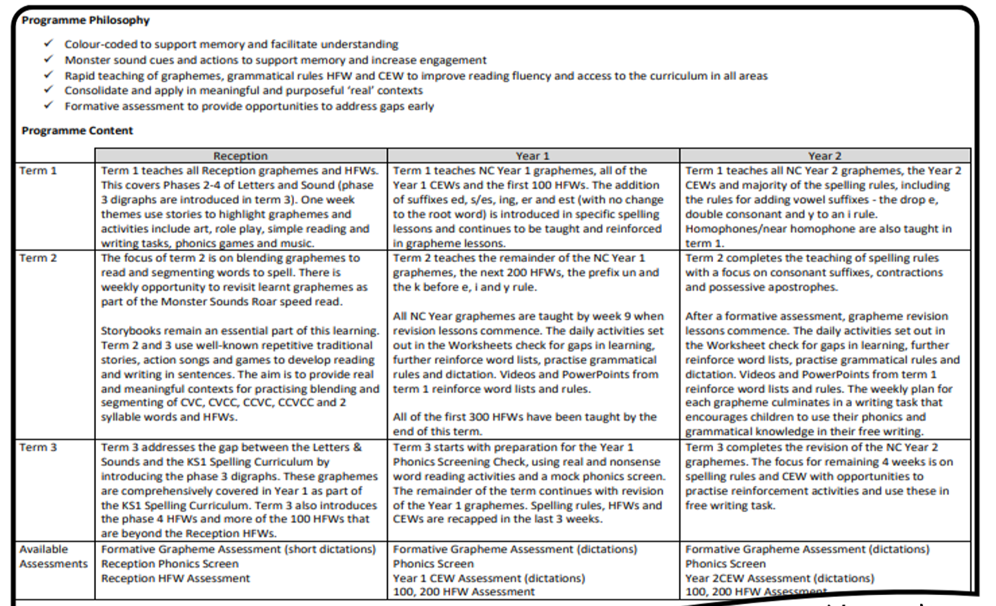

Each year group has a clear online termly plan broken down into year groups with a clear phonetic progression and structure.

Which is then broken down into a weekly plan.
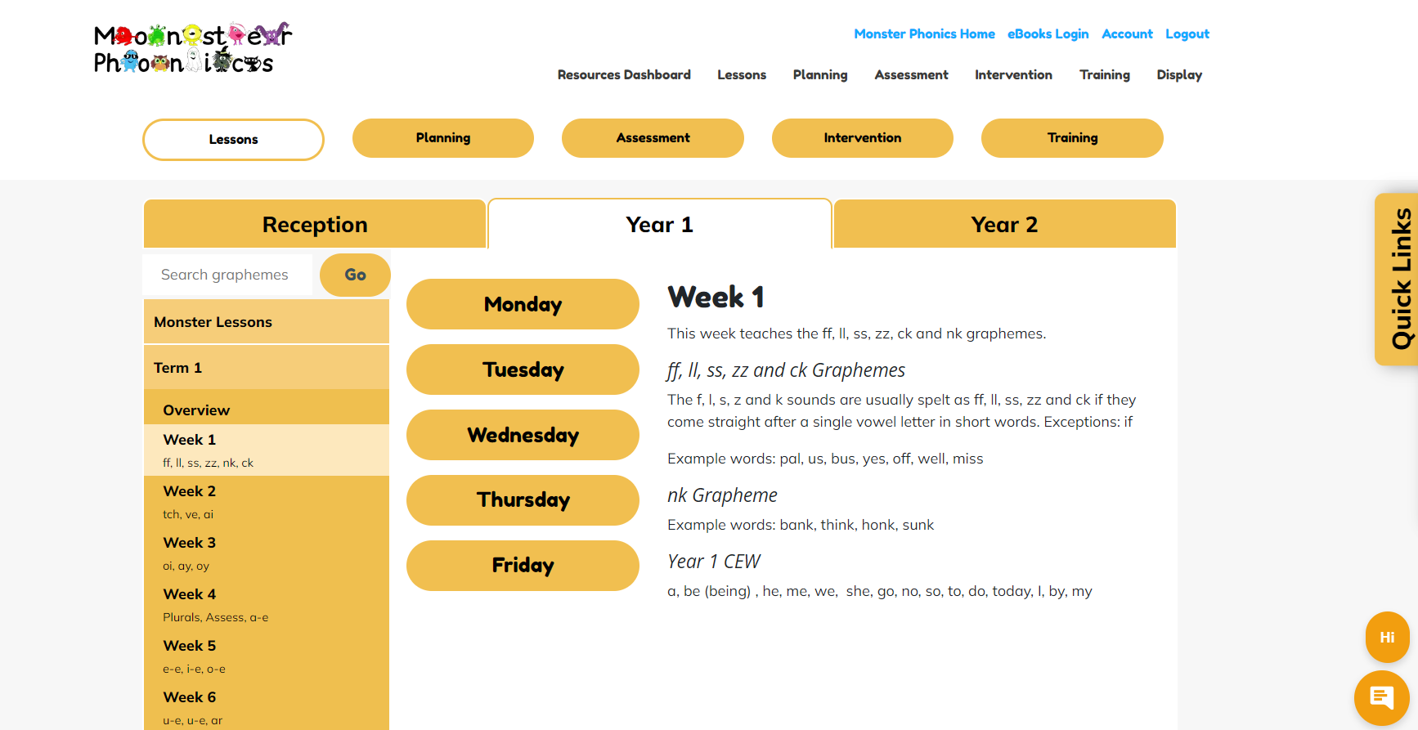
Each class then systematically follows the relevant year group plan by teaching a daily lesson.
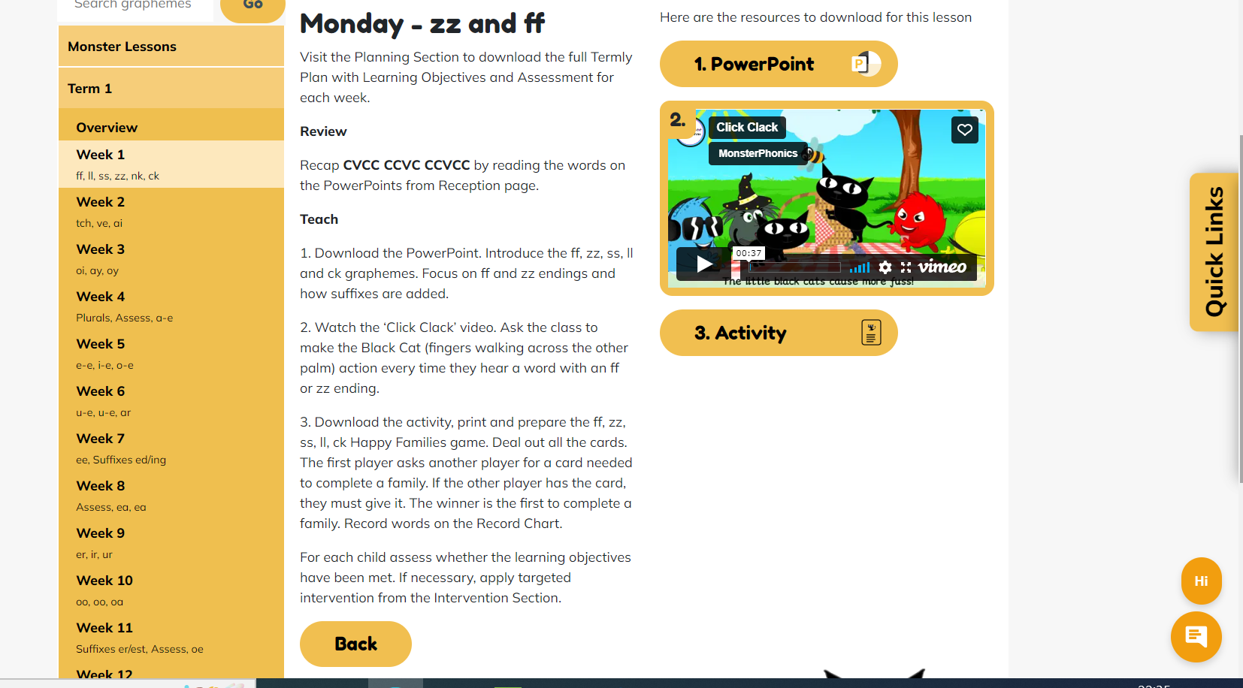
Children in our Reception classes also have phase 1 listening activities from the DFE’s ‘Letters and Sounds’ programme woven into their learning.

Lesson Structure
Phonics lessons within Cooperation Education East use the following sequence in all lessons:
Revise and Revisit
Teach
Practise
Apply
Plenary
Based on Research and support from our local English hub, each phonic lesson starts with a complete revisit of all the sounds that the children have been taught so far.
This is achieved by rotating the use of a fast-paced flashcard review or using a Monster Phonics learning wall/chart to review all the sounds that have been previously taught since EYFS up to a current point. Each lesson will contain reading and writing opportunities and as children progress in their use of phoneme and grapheme correspondence sessions will include additional sentence structure opportunities.

Assessment
Ongoing summative assessment within each year groups takes place in line with the phonics planning above. Appendix 1 demonstrates what will be assessed at each stage.
For spelling assessment is recorded at the points highlighted and is then saved on Pupil Asset where SLT can include the data in their monitoring process.
Each child has an individual sheet that follows into the next class (appendix 2).

In June of Year One the children take part in the National Phonics Screening program. Information for parents can be found on the school website. The results from the screening are discussed with the class teachers, head and deputy. Action plans are then created for children who have not attained the pass mark for them to retake the screening in June of Year Two. These results are shared with parents using the letter in Appendix 3.

From teacher’s daily assessments ‘target children’ partake in additional phonics interventions before the next phonics lesson. These interventions are included within the Monster phonics scheme.

Information from all of our assessments feed back into Teaching and learning so that gaps are identified and robustly addressed through additional intervention and targeted support within the classroom.

Monitoring of Phonics
Learning walk of phonics sessions week 3 of the first half of each half term.
Formal observations of phonics will take place in the fourth week of the second half of each term.
Phonics book scrutiny by NC, Literacy lead and HT the first week after each half term. Assessment on Pupil Asset (Phonics Tracker at Thompson) and the children's individual assessment sheet will also be monitored at this point.

Phonics Books

We introduce a ‘phonics book’ as part of our Trusts’ tailored approach that aims to support the children in their acquisition of phoneme (sounds) and graphemes (written representation of a sound) by developing early blending and segmenting skills. Children store the work they have completed in their phonics session here. This includes the activity completed and the practice and competition of words and sentences containing the lesson objective.

The weekly activities within the book are specific to our phonics teaching and alongside each weekly task; we support our parents/ carers by informing them of the phonemes, common exception and tricky words taught within the week. As a trust, we developed this system to support a gap in the confidence of our parents. We aim to equip them with the skills and knowledge that they need to best support their children (ie the pronunciation of phonemes, what to do when their child gets stuck).

Reading Books
Our phonetically decodable books are matched to the Monster Phonics Programme. Monster Phonics books ensure that children are reading using phonics that has been taught. Each book focuses on a key grapheme and ability-appropriate high-frequency words.
Phonic keywords and high-frequency word practice boxes at the start of each book help children to read the story with confidence. Stories include wow words and centre around the popular monster characters. Each book ends with questions to develop comprehension skills. These are used alongside carefully selected reading books which reflect the knowledge taught but provide our children with a further breadth of reading materials.
We have also extended our selection of reading books to include other publishers so children can experience a rich plethora of reading materials. All books are organised into phonic phases where the books consolidate and extend the children's learning from their phonics sessions.

Phonics and Spelling in Year 3, 4, 5 and 6 (Key Stage 2)
Spelling is taught in line with National Curriculum* expectations children have daily sessions working through the spelling rules. Where children are identified as needing phonics into KS2 it is delivered through Monster Phonics teaching and intervention. Thorough discussions with the previous teacher, together with time spent looking at the children’s assessments, it will ensure that gaps in learning are addressed.
*At Banham and Thompson the systematic and regular teaching of No Nonsense spelling is continued into KS2. Sessions are taught at least 3 times a week.

It is acknowledged that the Covid 19 pandemic in 2020/21 is likely to have had a significant impact on the teaching of phonics to children. Therefore, children particularly in Year 3 will be provided with regular phonics sessions and or regular teaching of Spelling No-nonsense to ensure gaps in learning are closed. The class teacher will discuss the need for this on either a group or class wide basis and the Trust deputy-head will provide further support, guidance and assistance to the class teacher one day per week in each school. This support is envisaged to consist of interventions in the form of small group work.

Intervention

After each lesson staff carry out, a formative assessment through questioning, observing and marking of work during the lesson. If children need intervention or booster groups to reach age-related expectations in phonics, this is provided in addition to the daily phonics session so that as many children as possible can access their year group learning objectives and reach age appropriate outcomes. The intervention is provided on the same day as the lesson for 10-15 minutes. All materials used prompt further understanding of the learning objective from the days’ phonics session. All interventions are provided online alongside the lesson objective using all resources from the programme including activities, planning, songs, games and power points.

Special Educational Needs and Disability

At Cooperative Education East we use planning and teaching flexibly in order to ensure individual needs are met and children achieve their full potential.

- Differentiation through tasks to stretch and challenge were appropriate,
- Support using adults and additional resources.
- Knowledge of children’s individual learning styles and interests.

Equal Opportunities

We are committed to providing a teaching environment conducive to learning. All children are valued, respected and encouraged to take risks in order to achieve regardless of ability, race, gender, religion, social background, culture or disability.

Parent Partnership

At Cooperative Education East we strongly believe that positive partnerships between staff and parents/carers are paramount in ensuring that children achieve their full potential. The importance of parents listening to children read regularly and taking part in phonics exercises set by the class teacher cannot be underestimated. Participating in this work will produce the best outcomes for Children. With this in mind we:
- Teachers to share phonemes, common exception and tricky words weekly.
- Parent/carers are invited into school to an information meeting to discuss how we teach phonics in school and to learn how they can support their children at home or take part in an online webinar.
- We send home phonetically decodable reading books for parents/carers to share with their child.
- In addition to regular Parents Evenings we strongly encourage parents to meet with teachers if they have any concerns about their child’s learning.
- Parents are also welcome to come into school to volunteer to hear readers, or to attend class-parent reading sessions, and to take part in reading cafes. This will allow parents to hear a text read and take part in activities linked to it.
- Letter to parents explaining the Year 1 Phonics Screening (appendix 4)
- Information on school websites and letters sent home about the teaching of phonics.

Appendices
- Assessment Schedule
- Individual Assessment Recording
- Results from Phonics Screening – Letter to Parents
- Letter to parents about upcoming check
Appendix 1 Assessment Schedule
RECEPTION ASSESSMENT SCHEDULE

ASSESSMENT 1
RECEPTION TERM 1 WEEK 7
GRAPHEMES
s a t p i n m d g o c k ck e u r h b f ff l ll ss
HFWs
a at as in it is I an and am dad to into go no the get dog can got on not cat of up mum put had oh him his big has he she me we be
FOCUS WORDS
sat nip nap dad gas cot kid sack ten run hop beg huff fill mess
___________________________________________________________
ASSESSMENT 2
RECEPTION TERM 1 WEEK 12
GRAPHEMES
j v w x y z zz qu ch sh th(v) th ng oo (long), ar
HFWs
if off you my they for was will all went from help too her with are yes then them that this, said
FOCUS WORDS
jug jam van vet wet win box six yak yell zip zap buzz fizz quick quack chin chap ship shut this that moth path long sang cool hoop car star

___________________________________________________________
ASSESSMENT 3
RECEPTION TERM 2 WEEK 6
GRAPHEMES
oo (short) ow ee ur ai or
HFWs
look now down see going just have it’s do so
FOCUS WORDS
book foot keep week fur surf rain sail for worn
___________________________________________________________
ASSESSMENT 4
RECEPTION TERM 2 WEEK 12
GRAPHEMES
oa er igh air oi ear ure
HFWs
come some were one like when little what by day away play children
FOCUS WORDS
coat, loaf, hammer, dinner, high, night, fair, pair, boil, soil dear, near, pure, sure
___________________________________________________________
ASSESSMENT 5
RECEPTION TERM 3 WEEK 11
GRAPHEMES
All graphemes that were not secure in term 1 and 2
HFWs
your, here, saw time, out, house, about made make came I’m, very, old called, asked, looked their our Mr, Mrs people could don’t
CVCC, CCVC, CVC + DIGRAPHS, CCVCC, CVC + POLYSYLLABIC, CCC ONSET
camp band frog twin bench train crisp drift helper giftbox spring crunch printer grasping
___________________________________________________________
YEAR 1 ASSESSMENT SCHEDULE
ASSESSMENT 1
TERM 1 WEEK 4
GRAPHEMES
ff ss zz ll ck nk tch ve ai oi ay oy
CEWs
be (being), he, me, we, she, no, go, so, to, do, today, I, by, my, love, some, come, was, is, his, has, one, once, friend, your, the, of, said, here, there, you, school
house, our, where, were, they, says, are, ask, put, push, pull, full
FOCUS WORDS
puff, miss, fizz, bell, back, think, honk, catch, witch, give, have, rain, sail, boil, toilet, stay, play, boy, enjoy
__________________________________________________________
ASSESSMENT 2
TERM 1 WEEK 8
GRAPHEMES
a-e e-e i-e o-e u-e u-e ar ee suffixes ing and ed
HFWs
from, help, back, will, this, that, then, them, with, went, children, animals, just, off, made, make, came, like, time, by, my, I, I’m, into, too, don’t, see, very, day, have, when, about, out, people
FOCUS WORDS
name, date, these, complete, kite, five, note, hole, rude, flute, cube, tune, arm, card, green, seen
___________________________________________________________
ASSESSMENT 3
TERM 1 WEEK 11
GRAPHEMES
ea ea er ir ur oa oo(u) oo suffixes er/est
HFW
Look, looked, asked, could, saw, all, down, now, Mr, Mrs, what, their, little, called
Focus Words
dream, heat, ready, instead, letter, summer, girl, twirl, burst, church, road, coach, took, book, zoo, food, grander, fresher
___________________________________________________________
ASSESSMENT 4
TERM 2 WEEK 2
GRAPHEMES
oe ou ow ow(long o) ue ue ew ew k before y/i/e
HFWs
more, horse, gone, live, would, school, soon, food, room, play, way, says, may, away, been, need, keep, feet, snow, grow, window, know, three, tree, trees, green, sleep, queen, please, ever, never, river, under, better, after, good, took, book, looks, looking, car, dark, park, hard, garden, found, round, around, mouse, shouted
FOCUS WORDS
toe, goes, about, found, how, town, snow, throw, blue, true, rescue, value, grew, flew, stew, few, kitten, Kent
___________________________________________________________
ASSESSMENT 5
TERM 2 WEEK 6
GRAPHEMES
ie ie igh or ore aw au air prefix un
HFWs
going, most, over, cold, told, gave, take, place, he’s, we’re, even, began, before, because, girls, birds, first, sea, tea, eat, each, really, these, other, mother, another, floppy, any, many, every, everyone, baby, only, suddenly, pulled
FOCUS WORDS
pie, tried, field, chief, light, might, morning, fork, snore, bore, draw, lawn, author, haunt, chair, stairs, unlock, unwell
___________________________________________________________
ASSESSMENT 6
TERM 2 WEEK 9
GRAPHEMES
ear (long e) ear (air) are y ph wh e o
HFWs
want, wanted, great, us, has, inside, liked, can’t, didn’t, key, hear, white, love, something, coming, fly, why, new, use, there, where, boy, which, head, dragon, animals, couldn’t, eyes, lived, boat, cried
FOCUS WORDS
year, dear, pear, wear, care, dare, party, happy, alphabet, dolphin, when, whisper, even, began, most, ago
___________________________________________________________
PHONICS SCREEN
TERM 3 WEEK 1
___________________________________________________________
ASSESSMENT 7
TERM 3 WEEKS 5
GRAPHEMES
All graphemes that were not secure in term 1 and 2.
HFWs
giant, find, laughed, again, friends, different, door, jumped, stopped, thought, through, magic, narrator, once, air, I’ve, I’ll, who, these
All HFWs that were not secure in previous assessments.
___________________________________________________________
ASSESSMENT 8
TERM 3 WEEK 9
GRAPHEMES
All graphemes that were not secure in term 1 and 2.
HFWs
All HFWs that were not secure in previous assessments.

YEAR 2 ASSESSMENT SCHEDULE

ASSESSMENT 1
TERM 1 WEEK 7: ASSESSMENT 1
GRAPHEMES
dge g c kn gn wr le el il al
CEWs
great break steak find mind kind behind wild child climb old gold hold cold told would could should door floor poor any many pretty move prove improve most both only every everybody even people whole clothes busy money hour Christmas thought
FOCUS WORDS
fridge, edge, gem, large, city, twice, knee, knight, gnaw, gnome, wrong, wrap, middle, candle, camel, travel, fossil, nostril, hospital, pedal, there, their, liking, shiny, patting, saddest, happiest, carried
­­­­­­­­­­­­­­___________________________________________________________
ASSESSMENT 2
YEAR 2 TERM 2 WEEK 2
GRAPHEMES
y al(or) o(u) ey w-a (o) w-or (er) w-ar (or) s (szsh) ti i
CEWs
grass class pass past fast last bath path father plant after again sure sugar water parents
beautiful eye who Mr Mrs
FOCUS WORDS
fry, reply, ball, walk, brother, nothing, donkey, chimney, wand, swap, work, worm, warm, forward, usual, vision, station, fiction, merriment, happiness, playful, happily, hopeless, plainness, can’t, don’t, the girl’s, my mum’s
­­­­­­­­­­­­­­___________________________________________________________
ASSESSMENT 3
TERM 2 WEEK 12
All graphemes and spelling rules not secure in previous assessments.
HFWs
may say way away play never ever river under better after grow snow know window car dark park hard garden our found round around mouse shouted good took book looks looking gone more horse live lived pulled want wanted need feet keep queen tree other mother another coming over going love something dragon sea tea eat each really please birds girl first soon food room school air where there right night use new us has head door which friends different would
­­­­­­­­­­­­­­___________________________________________________________
ASSESSMENT 4
TERM 3 WEEK 8
All graphemes and Focus Words not secure in previous assessments.
HFWs
gave take place began before because he's we're didn’t couldn't jumped stopped thought laughed magic animals I've I'll two once baby floppy suddenly these small bear boat home everyone town how through boy fly why cried giant narrator grandad morning rabbit that's things king across along
___________________________________________________________
ASSESSMENT 5
YEAR 2 TERM 3 WEEK 12
All Graphemes, Focus Words, HFWs and CEWs not secure in previous assessments.

Assessment for Monster Phonics
Learning walk of phonics sessions week 3 of the first half of each half term.
Formal observations of phonics will take place in the fourth week of the second half of each term.
Phonics book scrutiny by NC, Literacy lead and HT the first week after each half term. Assessment on pupil asset and the children's individual assessment sheet will also be monitored at this point.
Daily Formative Assessments
The first and most frequently used assessment will take place daily by the adult delivering the phonics session. Children who have not met the daily objective, as stated in the planning document for the lesson, are noted, and any gaps are addressed with a short recap at some point before the next discrete phonics session.
In addition to the ongoing weekly in-class assessment of learning outcome, formative reading assessments regularly track progress.
Formative Reading Assessment
EYFS formative reading assessments take place in weeks 7 and 12 of Term 1, weeks 6 and 12 of Term 2 and in week 12 of Term 3. They are tested 1 to 1 with an adult.
Yr 1 assessments take place in weeks 4, 8 and 11 of Term 1, weeks 3, 6 and 9 of Term 2 and in weeks 5 and 9 of Term 3 and week 5 and 9 in term 3. They are tested 1 to 1 with an adult.
YR 2 take place in week 7 of Term 1, weeks 2 and 12 of Term 2 and in weeks 8 and 12 of Term 3. They are tested 1 to 1 with an adult.
Spelling
EYFS
These assessments are for children who are ready to write. They are in the form of simple dictations, although may also be given as individual words. Formative assessments take place after Phase 2, in the middle of Phase 3, at the end of Phase 3 and at the end of Phase 4. A set of dictation sentences tests the spelling of each grapheme. Assessments can be broken up into smaller segments over several sessions. Children may use magnetic letters, a whiteboard or an iPad to write words. Individual record sheets allow the spelling of each of these graphemes to be recorded.
YR 1
Formative assessments take place after every 8 or 9 lessons. A group of graphemes and suffixes are tested through a set of dictation sentences, although may also be given as individual words. You may want to break the assessment up into smaller segments over several sessions. Individual record sheets allow the spelling of each of these graphemes to be recorded. These assessments can also be used to inform the teacher assessment frameworks at the end of key stage 1.
YR 2
There are 2 formative assessments, which take place after every 8 or 9 lessons. A group of graphemes and suffixes are tested through a set of dictation sentences. These can be broken up into smaller segments over several sessions. Individual record sheets allow the spelling of each of these graphemes to be recorded. These assessments can also be used to inform the teacher assessment frameworks at the end of key stage 1.
High Frequency and Common Word Assessment
High frequency word assessment use either the individual or the class record sheet to record spellings. The individual record sheet is useful for children requiring learning support and has multiple entries for the same time to record progress. The record sheets test words in the order of frequency with the most frequent words being highest on the list.
The colour-coded record highlights the phonetic areas that require focus. For example, if most words with ‘ee’ or with a silent letter are spelt incorrectly, these graphemes require a review.
Records can be added to after a period of time, to mark progress.
Common exception words are tested through dictations in a format that is useful for the teacher assessment frameworks at the end of key stage 1. The results are recorded on an individual colour-coded record, which gives some additional insight into spelling as described above. Either print and tick each box or open the document in Word and use the highlighting tool to highlight each box. This allows the record to be stored and shared digitally. Records can be added to after a period of time, to mark progress.
Summative End of Year Phonics Screening Test
This summative assessment is aligned to the end of Year 1 phonics screen and is useful preparation for this test. As this test includes every grapheme within the Year’s curriculum, it is a longer version. Select a section to test at any one time.
­­­­­­­­­­­

Appendix 2 Individual Assessment Recording

R/Y1/Y2 Grapheme and CEW Record Name __________ Date of Birth __________

Date of Assessment
_ _ / _ _ / _ _ _ _ / _ _ / _ _ _ _ / _ _ / _ _ _ _ / _ _ / _ _ _ _ / _ _ / _ _ _ _ / _ _ / _ _

Phase 2 Graphemes
 | s | a | t | p | i | n | m | d | g | o | c | k | ck | e | u | r | h | b | f | ff | l | ll | ss
Read
Write

Phase 3 Graphemes
 | j | v | w | x | y | z | zz | qu | ch | sh | th(v) | th | ng | ai | ee | igh | oa | oo | oo (u) | ar | or | ur | ow | oi
Read
Write

 | ear | air | ure | air | er
Read
Write

 | sat | mop | rug | box | wig | ten | can | lot | did | hip | jog | van | kid | quit | shed | chop | thin | this
Read
 | sad | men | rat | fox | wag | tin | cot | let | dog | hen | jab | vet | nit | quiz | shop | chin | bath | that
Write
Phase 4 CVC+ Words

Reception High-Frequency Words

 | a | It | in | at | on | am | up | dog | and | big | mum | can | get | cat | dad | yes | went | this | for
Read
Write

 | they | day | play | away |  |  | he | she | we | me | see
Read |  |  |  |  |  | Read
Write |  |  |  |  |  | Write

 | I | like | my |  |  | no | go | going |  |  | to | you
Read |  |  |  |  | Read
Write |  |  |  |  | Write
 | the | is | was | look | of | all | said | are | come
Read
Write

Year 1 Assessment Name __________ Date of Birth

Date of Assessment
_ _ / _ _ / _ _ _ _ / _ _ / _ _ _ _ / _ _ / _ _ _ _ / _ _ / _ _ _ _ / _ _ / _ _ _ _ / _ _ / _ _

Read | ff | ll | ss | zz | ck | nk | ur | or | ph | ai | ay | a-e
 | off | well | miss | buzz | back | think | turn | short | phonics | rain | stay | made
Write | huff | full | less | fizz | rock | bank | hurt | born | dolphin | wait | way | came

Read | e | ee | ea | ie | y | e-e | i-e | ie | igh | o | o-e | oa | oe | ow | u-e | ue | ew
 | me | tree | each | thief | happy | these | five | pie | high | going | home | boat | goes | grow | use | Tuesday | new
Write | be | green | Dream | field | very | theme | ride | tie | night | don’t | woke | road | toe | show | tube | rescue | few

Read | o | oo | u-e | ue | ew | ou | ow | tch  silent t | ea  silent a | ore  silent e | ve  silent e | wh  silent h
 | today | food | June | true | threw | about | how | catch | meant | woree | have | which
Write | do | pool | rule | blue | flew | out | now | fetch | head | moree | livee | when

Read | oy | oi | ar | er  stressed | er  unstressed | air | ir | oo  (u) | aw  (or) | au  (or) | ear  (air) | are  (air) | ear  (long E-r)
 | boy | coin | park | term | under | chair | girl | book | draw | dinosaur | wear | dare | near
Write | toy | soil | car | her | better | hair | bird | took | yawn | August | bear | care | year
Common Exception Words
 | says | they |  |  | be | he | me | she |  |  | I | by | my
Read |  |  |  | Read |  |  |  |  |  | Read
Write |  |  |  | Write |  |  |  |  |  | Write

 | no | go | so |  |  | do | to | today | you | school |  |  | house | our
Read |  |  |  |  | Read |  |  |  |  |  |  | Read
Write |  |  |  |  | Write |  |  |  |  |  |  | Write
 | your | friend | are | love | come | some | onee | once |  |  | the | said | of | were | was | is | his | has | here | there
Read |  |  |  |  |  |  |  |  |  | Read
Write |  |  |  |  |  |  |  |  |  | Write

Regional Differences Stress Emphasis
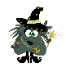 | ask | put | push | pull | full |  |  | a
Read |  |  |  |  |  |  | Read
Write |  |  |  |  |  |  | Write

Year 2 Assessment Name __________ Date of Birth

Date of Assessment
_ _ / _ _ / _ _ _ _ / _ _ / _ _ _ _ / _ _ / _ _ _ _ / _ _ / _ _ _ _ / _ _ / _ _ _ _ / _ _ / _ _

Graphemes
Read | ey | i | y | n  silent k | n  silent g | r  silent w | o  (u) | dge  (j) | g  (j) | c  (s)
 | donkey | find | fly | knock | gnaw | wrote | nothing | badge | huge | race
Write | key | child | try | knee | gnat | wrong | other | dodge | giant | city
Read | le  (schwa-l) | el  (schwa-l) | il  (schwa-l) | al  (schwa-l) | al  (or) | wor  (er) | wa  (a) | war  (or) | ti  (sh) | S  (zh)
 | table | camel | pencil | hospital | walk | work | watch | warm | station | usual
Write | middle | travel | fossil | animal | ball | word | want | award | fiction | treasure

Common Exception Words
 | great | steak | break |  |  | every | busy | any | many | pretty | everybody | even | people | money
Read |  |  |  |  | Read
Write |  |  |  |  | Write

 | find | kind | mind | behind | child | wild |  |  | most | only | both | old | cold | gold | hold | told | hole | clothes
Read |  |  |  |  |  |  |  | Read
Write |  |  |  |  |  |  |  | Write

 | new | beautiful |  |  | move | prove | improve | who |  |  | hour
Read |  |  |  | Read |  |  |  |  |  | Read
Write |  |  |  | Write |  |  |  |  |  | Write

 | could | would | should | Christmas | floor | door | poor
Read
Write

 | Mr | Mrs | water | sure | sugar | parents | eye
Read
Write

 | after | fast | last | past | father | class | pass | grass | path | bath | plant
Read
Write

Appendix 3
Phonics screening check information and results
What is the phonics screening check?
The phonics screening check is a quick check of your child’s ability to decode words using only his or her phonic knowledge. It helps us to confirm whether your child has met the expected standard for a child at the end of Year 1.
The check is a statutory requirement for all children in Year 1 and takes place each year in the summer term. Children who did not take the check in Year 1, or who did not meet the expected standard, will take the check again at the end of Year 2.
The check was carried out in school during this year during week commencing ? June 2013.
How does the check work?
- Your child was asked to read 40 words aloud to a teacher who is known to him/her.
- Your child may have read some of the words before, while others would have been completely new.
- The check took only a few minutes to complete and there was no time limit.
Meeting the expected standard
In order for children to demonstrate that they have met the expected standard in phonic decoding, they had to score at least [level threshold to be inserted] marks in the phonics screening check. Children who scored fewer than [level threshold to be inserted] marks are considered not to have met the expected standard in phonic decoding. Any child who has not met the expected standard will be given additional support in phonics to help him or her to improve. The nature of this support will vary depending on how close to the threshold he/she was.
Your Child’s Score

Name: ……………………………………………………………..

……………….. out if 40

Your child has/not met the expected standard in phonics decoding.

What happens if my child failed the phonics screening?
If a child does not achieve the required passing grade during the phonics screening test, they will be given extra support over the course of the next school year to improve their abilities at reading and decoding words. At the end of year 2, they will then be able to retake the screening test.
If you have any questions or wish to discuss this further please feel free to contact your child’s class teacher.

Appendix 4
Year 1 Phonics Screening Check 2022
Dear Parent/Carer,
As you are aware, all children within Year 1 will take part in a statutory Year 1 Phonics Screening check in June.
What happens in the Phonics Screening Check?
The test is designed to assess your child’s reading skills via 40 words split into two sections. Each section consists of 10 real words and 10 pseudo-words (non-sense or ‘alien words’). These pseudo words are included because your child will need to be able to use their phonic knowledge and decoding skills to be able to read any word they come across as they progress within the school. This enables children to learn new words themselves by gaining an understanding through the context in which it has been placed.
Do we get to know the results?
We have to report the results to the local authority by the end of the summer (year 1) term. We’ll also let you know the results before the summer holidays.
If your child does not meet the expected standard in the check, they’ll get to have another go next year (for year 1) or in the summer term (for year 2). It’s normally nothing to worry about.
The results do not count towards any league tables.
How can I support my child?
Please continue to read at home daily including practising to read ‘alien words’.
Watching our Monster Phonics webinar which explains what phonics is and how it is taught.
For more information about the phonics screening tests please visit the school website or watch Parent video: The Phonics Screening Check - YouTube .
If you have any questions or queries please speak to your child’s class teacher.

