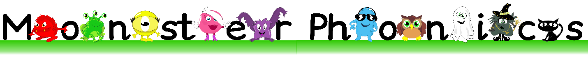 Dear Parents/Carers,
At Co Operative Education East (CEE) we have made the exciting move to follow the Monster Phonics DfE approved phonics scheme. Monster Phonics is a rigorous, systematic synthetic programme which will help us to develop fluency, vocabulary and comprehension skills. By combining the technical skills needed to read alongside an enjoyment of and in reading we want children to possess a love of reading.Monster Phonics accelerates progress, so it is important to use this approach at home whenever you are helping your child with phonics or learning spellings.
We know that children learn best when parents and teachers follow the same methods. Working in the same way is vital for reinforcing learning. So here is some information to help you use the Monster Phonics approach which we are now implementing across the trust.
Please find attached your parent login. You can use this to access Monster Phonics resources on their website. Each week, your child’s class teacher will share their current learning with you. They may suggest that you have a go at certain activities or watch specific videos at home. They may also suggest that you download resources such as Flashcards and PowerPoints to support home learning. If you have any questions or need further support, please speak to your child’s class teacher.
Your log in details Username:
Password:
To log in click Monster Phonics Programme in the blue menu bar. Then click Lessons or click on the link shared by your child’s teacher. Follow the ‘Parent Guide’ to help you best support your child reading Monster Phonics books. If at any point you encounter any problems, please contact info@monsterphonics.com
The Monster Phonics Reading Scheme
You will also notice a change to our reading books where we will be using Monster Phonics books to practice and embed your child’s learning from the week.
The next pages outline the way Monster Phonics works. Monster Phonics makes learning fun and more memorable. Rather than relying on rote learning, Monster Phonics uses colour-coding to promote understanding, which leads to children becoming confident, independent learners. Confidence builds their passion for school and for life.
Should you have any further questions or wish to discuss this further please do not hesitate to contact me at nclarke@cee.coop
Thank you for your ongoing support
Mrs Clarke

What is Monster Phonics?
The 26 letters of the alphabet and combinations of these letters make 44 speech sounds in English. The 44 sounds (phonemes) are spelt by 144 different letter combinations (graphemes). For example, the sound A is spelt several different ways, including ay (play) and ai (train).
Traditional ways of learning to spell can be time-consuming and for some children they are ineffective. Monster Phonics teaches children to read by enabling them to identify the individual graphemes (letter combinations) and blend the sounds (phonemes) together to read the word.
To support this process, Monster Phonics uses the 10 monsters to categorise all sounds into 10 simple areas. Furthermore, each monster has a different colour and that colour represents that way of spelling the sound.
Each week the phoneme your child has been working on in school will be shared with you via class dojo.
To find out more about how Monster Phonics works please visit https://monsterphonics.com/how-it-works/

Why does it improve learning?

The child learns through the assignment of colour and the linkage of the sound, as well as seeing the colour, creating more ways of remembering the spelling.
Your teacher will be using games, songs and activities that continuously reflect this way of learning, so that structure is constantly seen, heard and experienced by your child. This consistency is critical in ensuring that a complicated language is learnt in the most simplistic way. Therefore it is essential that you use Monster Phonics.

Find out more about Monster Phonics
- Attend one of our Parent Webinars
- Watch a Monster Phonics Story Time (available on you tube)
- Read a review and if you like Monster Phonics, add one too!

Meet the Monsters
Long A Sound | Long O Sound | Long E Sound | Long U Sound
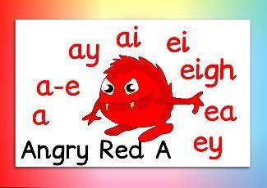 | 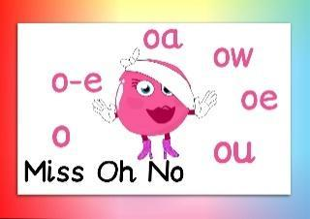 | 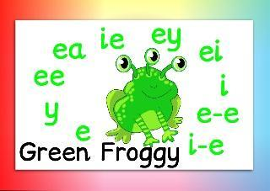 | 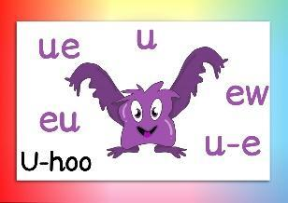
Long I Sound | Long oo Sound | Long ow Sound | Black Cats =Phonic Letters
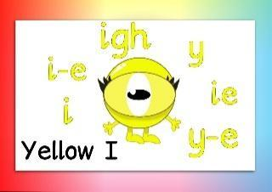 | 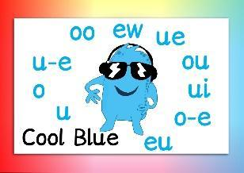 | 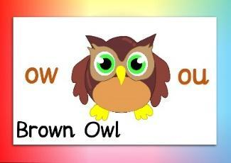 | 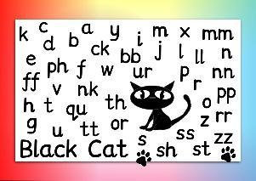
Tricky letters that make a different sound |  | Silent letters that have no sound
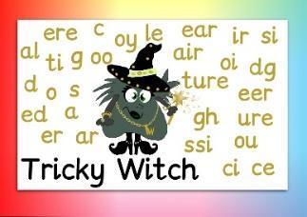 |  | 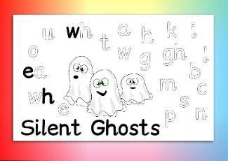
Monster Phonics Products
Free resources for parents
Activities
https://monsterphonics.com/free-phonics-worksheets/

Ideas for learning spellings
https://monsterphonics.com/free-resources/fun-ways-to-help-children-learn-phonics-spelling/

Games
https://monsterphonics.com/games/

Flashcards
https://monsterphonics.com/flashcards-2/

Information about phonics
https://monsterphonics.com/how-it-works/letters-and-sounds/
https://monsterphonics.com/how-it-works/ks1-spelling-curriculum/
https://monsterphonics.com/the-phonics-screening-check/

