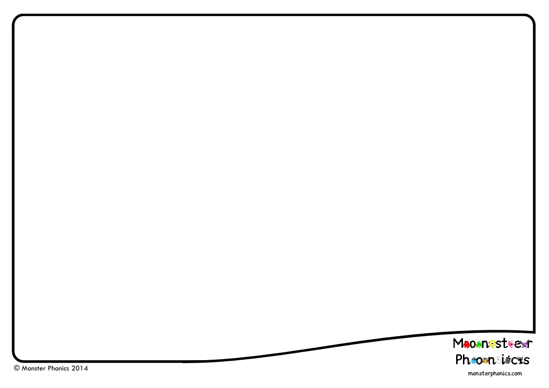
Programme Philosophy
- Colour-coded to support memory and facilitate understanding
- Monster sound cues and actions to support memory and increase engagement
- Rapid teaching of graphemes, grammatical rules HFW and CEW to improve reading fluency and access to the curriculum in all areas
- Consolidate and apply in meaningful and purposeful ‘real’ contexts
- Formative assessment to provide opportunities to address gaps early
Programme Content
 | Reception | Year 1 | Year 2
Term 1 | Children are single letter GPCs. Starting with graphemes s, a, t and p, children are taught to blend and segment simple words such as sat, pit, tap. As additional graphemes are learnt each week, the number of simple words that can be blended and segmented increases. The sets increase in complexity as the scheme progresses, with single letters being taught first, leading to digraphs. | Term 1 teaches NC Year 1 graphemes, all of the Year 1 CEWs and the first 100 HFWs. The addition of suffixes ed, s/es, ing, er and est (with no change to the root word) is introduced in specific spelling lessons and continues to be taught and reinforced in grapheme lessons. | Term 1 teaches all NC Year 2 graphemes, the Year 2 CEWs and majority of the spelling rules, including the rules for adding vowel suffixes - the drop e, double consonant and y to an i rule. Homophones/near homophone are also taught in term 1.
Term 2 | Term 2 teaches digraphs and trigraphs and practise of blending and segmenting longer words. It also practises the phonics that has already been taught and continues to develop knowledge of the Reception HFWs also introduces more of the 100 HFWs.  Repetitive stories provide a theme for this learning. Term 2 and 3 use well-known traditional stories to develop reading and writing in sentences. The aim is to provide real and meaningful contexts for practising blending and segmenting. | Term 2 teaches the remainder of the NC Year 1 graphemes, the next 200 HFWs, the prefix un and the k before e, i and y rule. All NC Year graphemes are taught by week 9 when revision lessons commence. The daily activities set out in the Worksheets check for gaps in learning, further reinforce word lists, practise grammatical rules and dictation. Videos and PowerPoints from term 1 reinforce word lists and rules.  All of the first 300 HFWs have been taught by the end of this term. | Term 2 completes the teaching of spelling rules with a focus on consonant suffixes, contractions and possessive apostrophes. After a formative assessment, grapheme revision lessons commence. The daily activities set out in the Worksheet check for gaps in learning, further reinforce word lists, practise grammatical rules and dictation. Videos and PowerPoints from term 1 reinforce word lists and rules. The weekly plan for each grapheme culminates in a writing task that encourages children to use their phonics and grammatical knowledge in their free writing.
Term 3 | Term 3 teaches and practices the blending and segmenting of words consisting of 4 letters or more (CVCC, CCVC, CCC onset, CCVCC include previously taught digraphs and polysyllabic words). There is regular opportunity to revisit learnt graphemes. HFW continue to be taught. | Term 3 starts with preparation for the Year 1 Phonics Screening Check, using real and nonsense word reading activities and a mock phonics screen. The remainder of the term continues with revision of the Year 1 graphemes. Spelling rules, HFWs and CEWs are recapped in the last 3 weeks. | Term 3 completes the revision of the NC Year 2 graphemes. The focus for remaining 4 weeks is on spelling rules and CEW with opportunities to practise reinforcement activities and use these in free writing task.
Available  Assessments | Formative Grapheme Assessment (short dictations)  Reception Phonics Screen  Reception HFW Assessment | Formative Grapheme Assessment (dictations)  Phonics Screen  Year 1 CEW Assessment (dictations)  100, 200 HFW Assessment | Formative Grapheme Assessment (dictations)  Phonics Screen  Year 2CEW Assessment (dictations)  100, 200 HFW Assessment

